Midterm Report
Project 3 — Bias and Trust Analysis in Healthcare AI Summaries
Topic: Alzheimer’s Disease
Articles
- “2024 Alzheimer’s Disease Facts and Figures.” Alzheimer’s & Dementia: The Journal of the Alzheimer’s Association, U.S. National Library of Medicine, 2024, https://pubmed.ncbi.nlm.nih.gov/38689398/.
- Altuna, Miren, et al. “Stepwise Approach to Alzheimer’s Disease Diagnosis in Primary Care Using Cognitive Screening, Risk Factors, Neuroimaging and Plasma Biomarkers.” Nature News, Nature Publishing Group, 27 Aug. 2025, https://ww.nature.com/articles/s41598-025-17394-3.
- Parums, Dinah V. “A Review of the Current Status of Disease-Modifying Therapies and Prevention of Alzheimer’s Disease.” Medical Science Monitor : International Medical Journal of Experimental and Clinical Research, U.S. National Library of Medicine, 13 May 2024, https://pmc.ncbi.nlm.nih.gov/articles/PMC11097689/
- Zhang, Jifa, et al. “Recent Advances in Alzheimer’s Disease: Mechanisms, Clinical Trials and New Drug Development Strategies.” Nature News, Nature Publishing Group, 23 Aug. 2024, https://www.nature.com/articles/s41392-024-01911-3#Abs1.

Project Pipeline Diagram
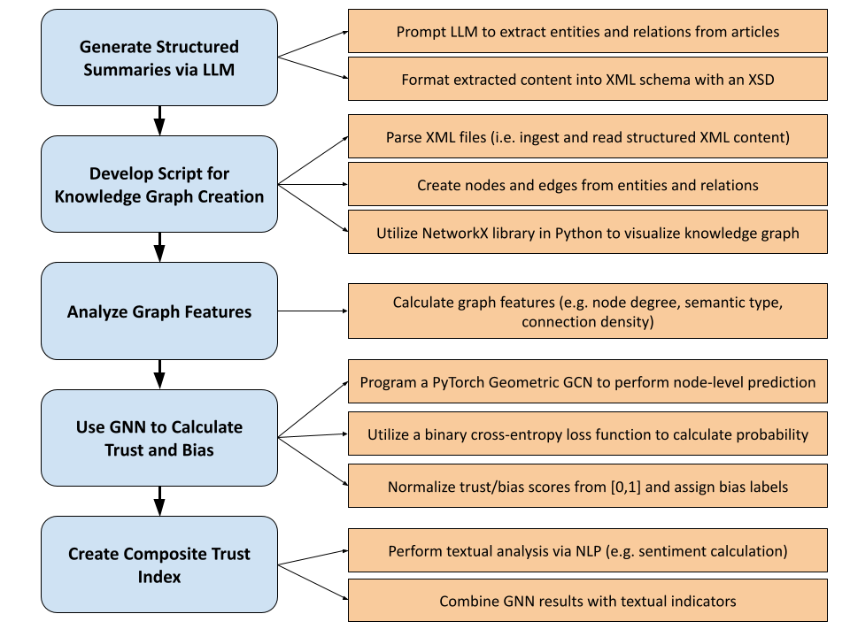

LLM-Generated Structured Summaries
Article 1 (“2024 Alzheimer’s Facts and Figures”):
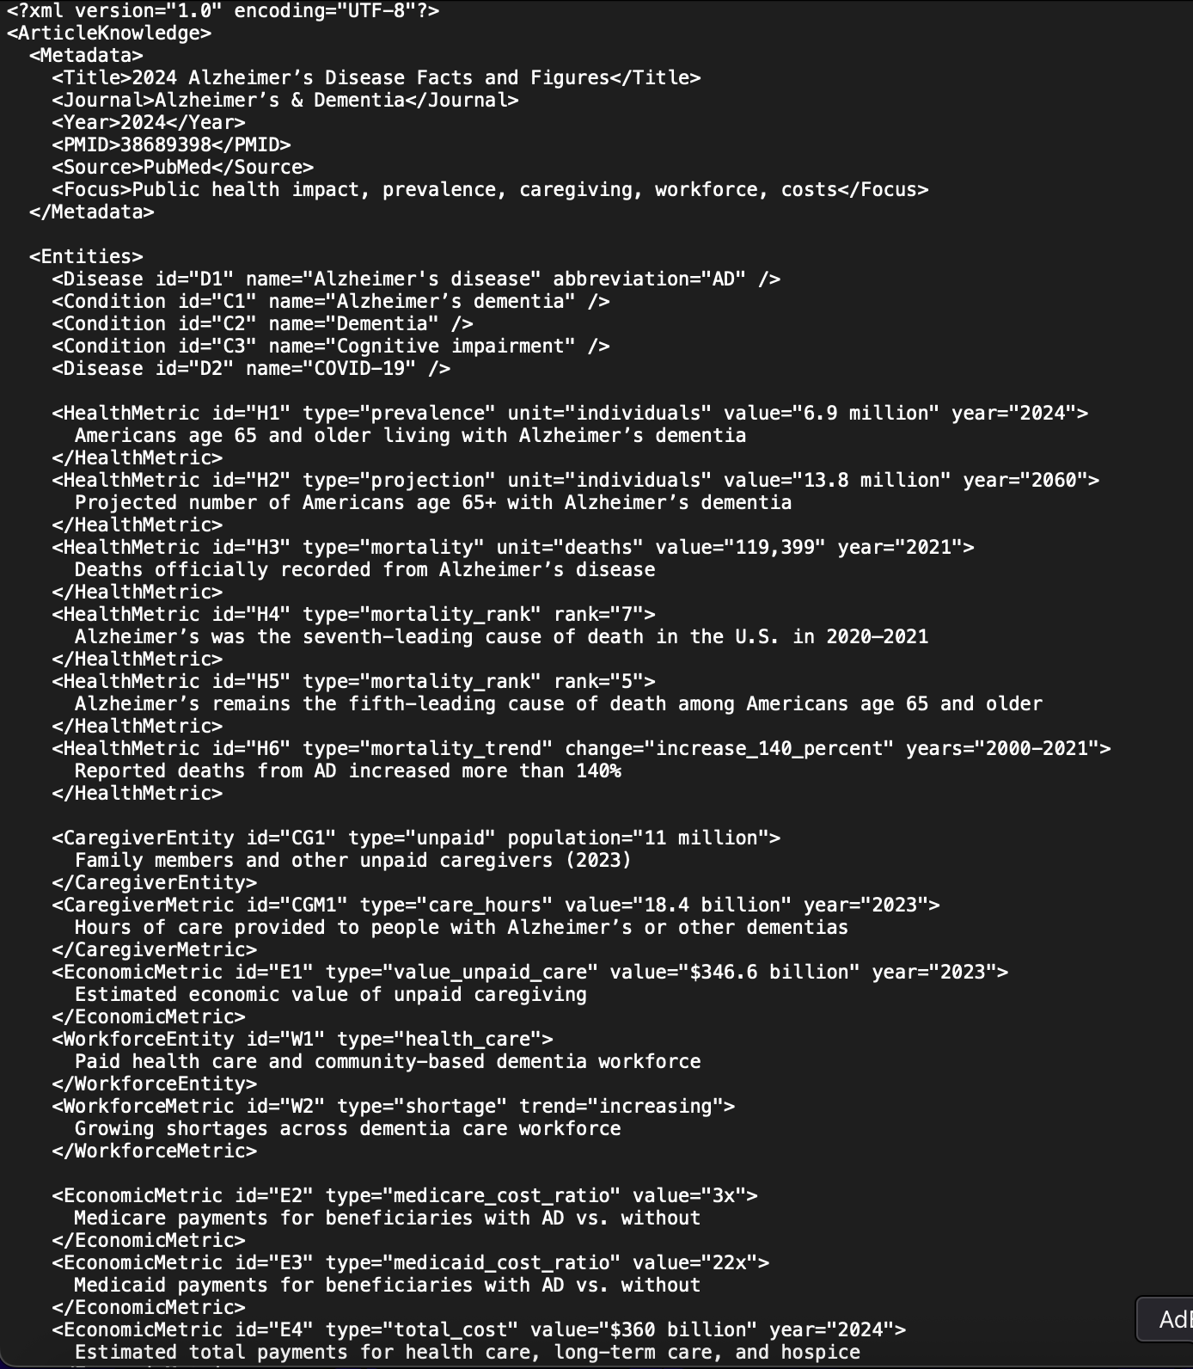
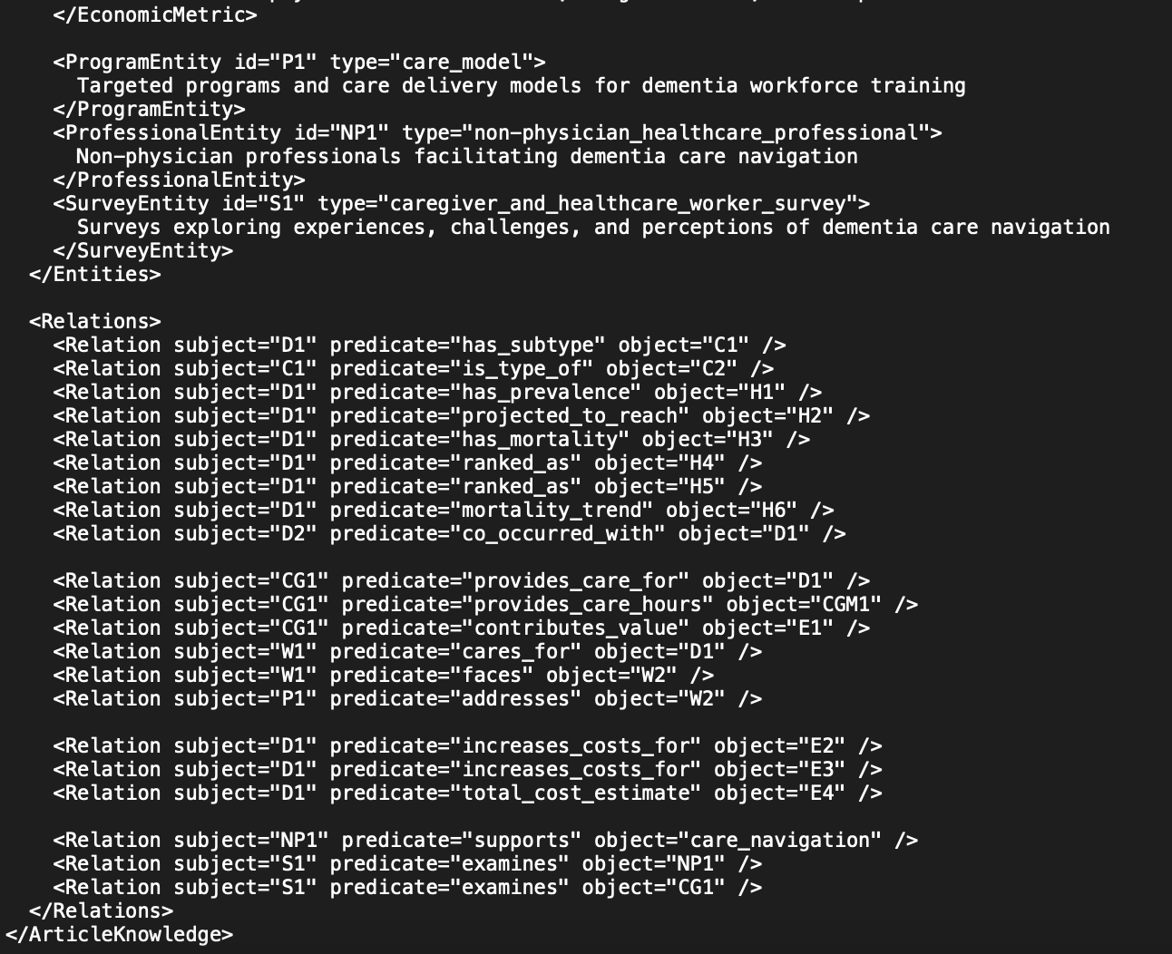

Article 2 (“Stepwise Approach to Alzheimer’s Disease Diagnosis …”):
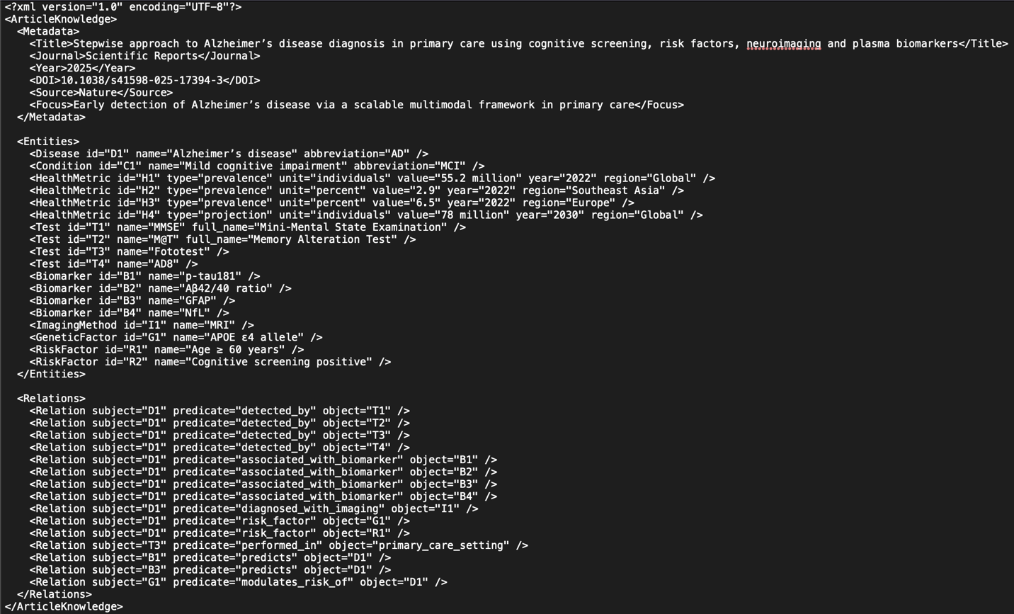

Article 3 (“A Review of the Current Status of Disease-Modifying Therapies …”):
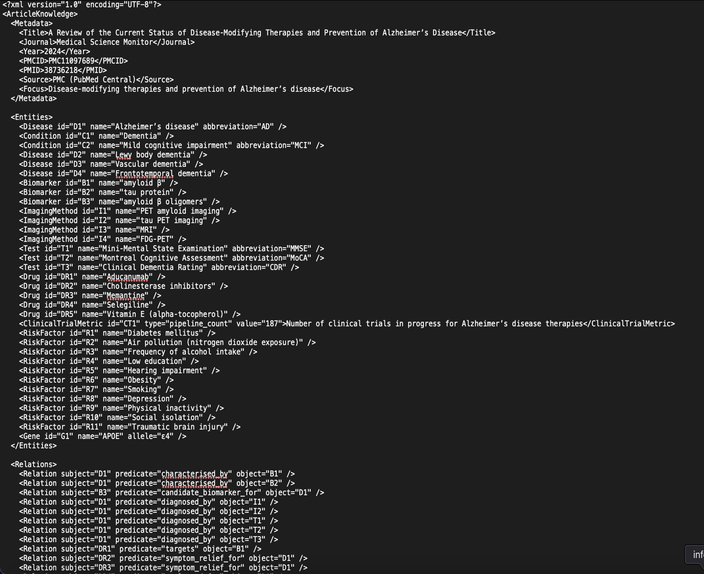
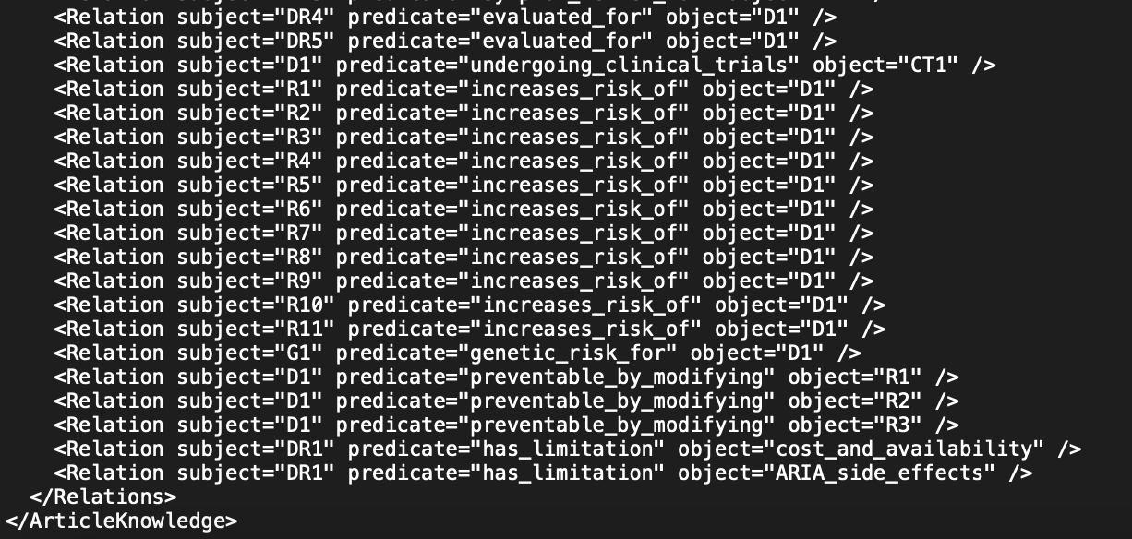
Article 4 (“Recent Advances in Alzheimer’s Disease: Mechanisms …”)
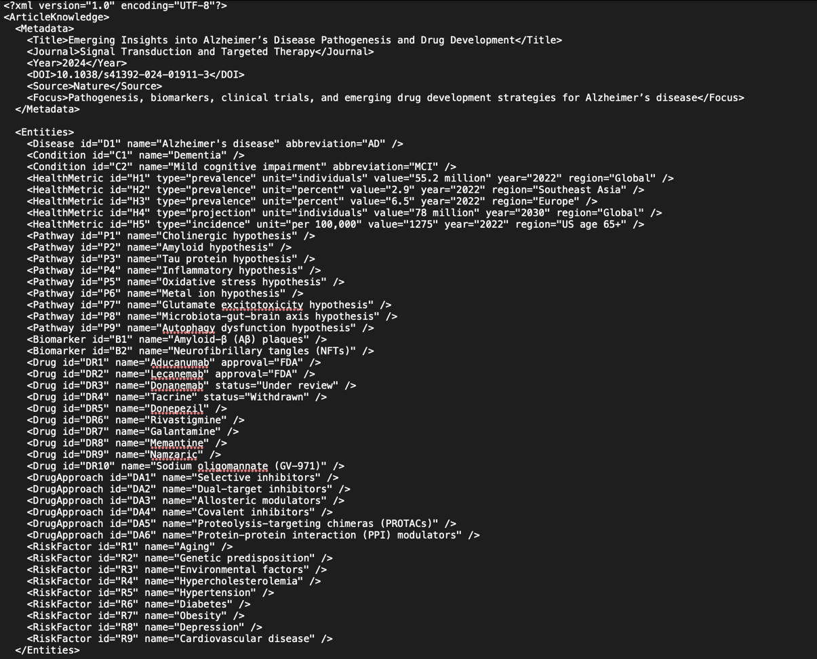
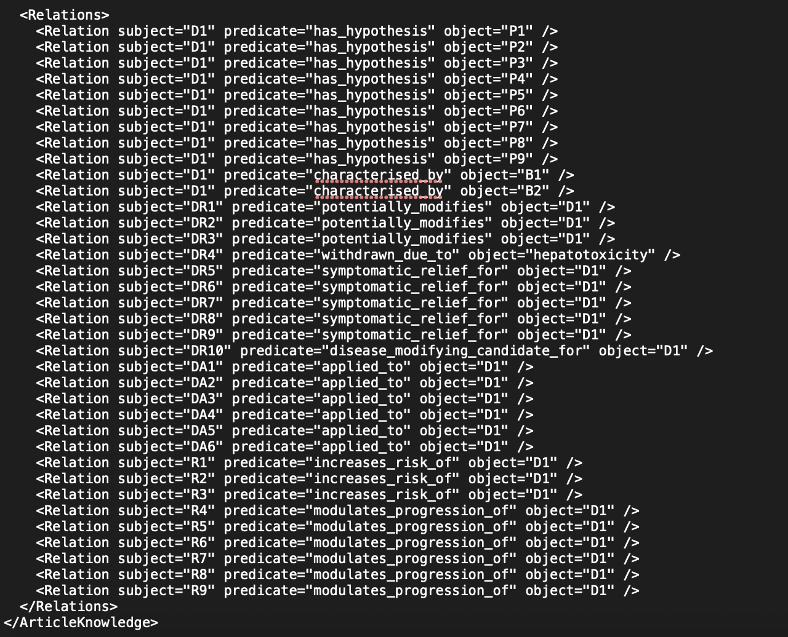
Preliminary Knowledge Graph Creation Script
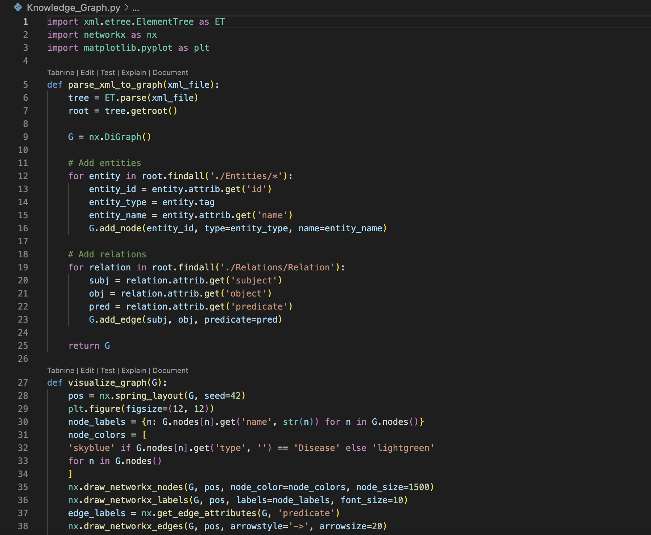
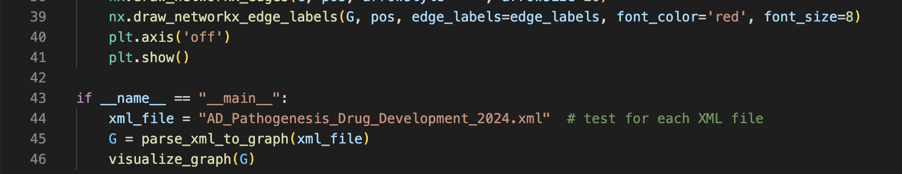

Sample Knowledge Graph
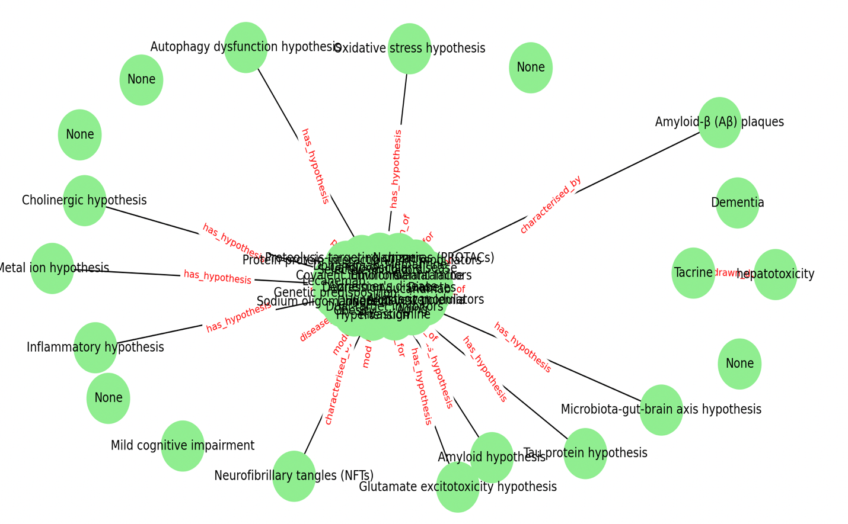
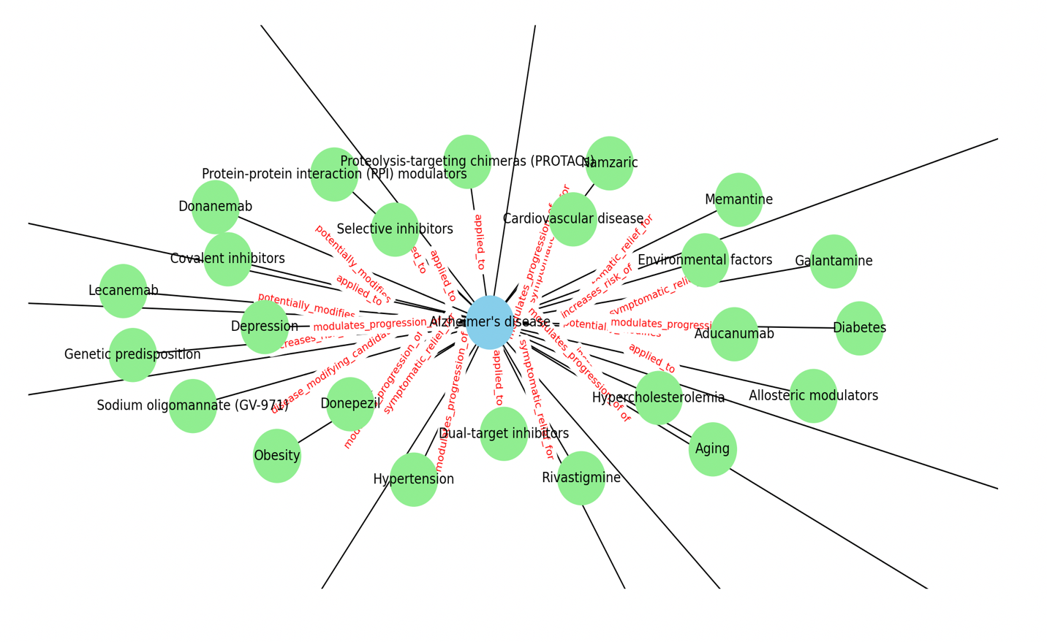

Next Steps
- Develop XML Schema Definition to improve Knowledge Graph
- Develop a script to create a knowledge graph merging content from all four articles
- Program GNN Module to calculate trust/bias scores
- Calculate textual indicator metrics (e.g. sentiment analysis)
- Create composite trust index merging GNN results with NLP metrics

